Uploading Files and Folders to GitHub Desktop
This document provides a clear, step-by-step guide for both technical and non-technical users to upload a file or folder to GitHub using GitHub Desktop.

1. Install GitHub Desktop
- Go to the official GitHub Desktop website - https://desktop.github.com/download/
- Download the installer for your operating system.
- Run the installer and complete the setup.

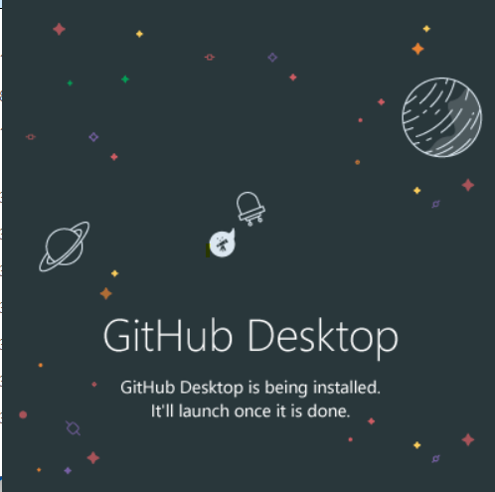

2. Sign In to Your GitHub Account
- Open GitHub Desktop.
- When prompted, sign in using your GitHub credentials.
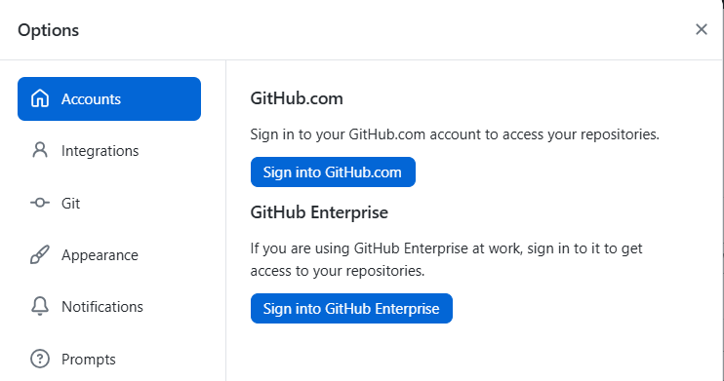

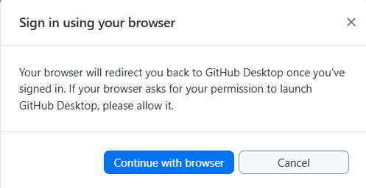

3. Create or Select a Repository
You have two options:
Option A: Create a New Repository
- Click File → New Repository.
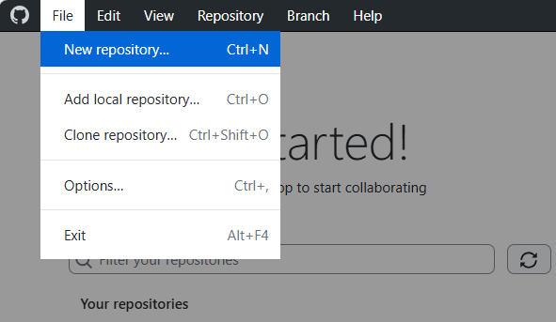
- Enter a name, description (optional), and choose a local folder.
- Click Create Repository.
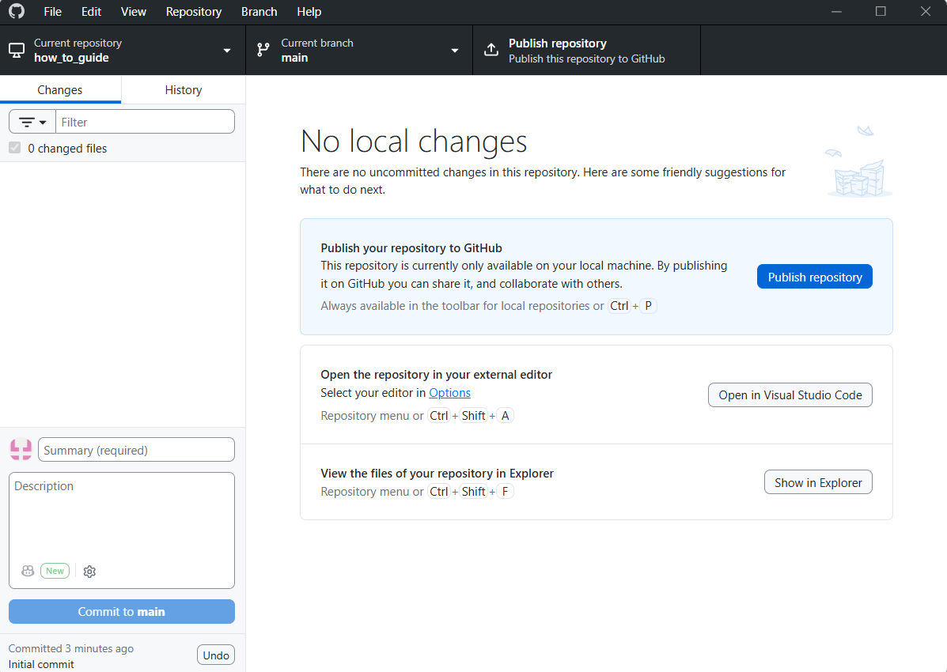

Option B: Clone an Existing Repository
- Click File → Clone Repository.
- Choose a repository from your GitHub account.
- Select a local path and click Clone.
[Insert Screenshot Here]

4. Add Files or Folders to the Repository
You can add content in two ways:
Method A: Drag and Drop
- Open the repository folder on your computer.
- Drag your file or folder into it.
Method B: Use File Explorer/Finder
- Copy and paste your files into the repository folder.
GitHub Desktop will automatically detect the new files.
[Insert Screenshot Here]

5. Review Changes in GitHub Desktop
- Open GitHub Desktop.
- Go to the Changes tab.
- You will see all added or modified files.
- Add a Summary (required) and Description (optional).
[Insert Screenshot Here]

6. Commit Your Changes
- Click Commit to main (or your current branch).
This saves your changes locally.
[Insert Screenshot Here]

7. Push Changes to GitHub
- Click Push origin at the top.
Your files are now uploaded to GitHub.
[Insert Screenshot Here]

8. Verify on GitHub.com
- Open your repository on GitHub.com.
- Refresh the page.
- You should now see your uploaded files.
[Insert Screenshot Here]

Summary
This guide covered:
- Installing GitHub Desktop
- Creating or cloning a repository
- Adding files or folders
- Committing and pushing changes
- Verifying uploads on GitHub
You can now insert your screenshots in the placeholders above to complete the document.

